04/02/2025 18:43:47

EDO Data Engineering Coding Standards and Best Practices

Revision History
Date | Version | Prepared By | Description of version and changes | Reviewed by | Approved by
4/8/2024 | 0.0 | Vinod Shinde) | Initial Version
5/23/2024 | 1.0 | Vinod Shinde | Added Email Templates
10/4/2024 | 2.0 | Vinod Shinde | Added section 1.1 ADF Git Setup
03/31/2025 | 3.0 | Aruna Evoori | Added the details for the Standard (1.5.4), Databricks Cluster (2.3.3) and Tidal (3.0)

Table of Contents
1 Azure Data Factory 3
1.1. ADF Git Setup (Important to note!!!) 3
1.2. IIG Framework 4
1.3. Security Considerations 4
1.1.1. Inputs and Outputs: 4
1.1.2. Credentials: 5
1.4. Parallelism: 5
1.4.1. Parallel Execution: 6
1.4.2. Service Limitations: 6
1.5. Reusable Code: 6
1.5.1. Dynamic Linked Services: 6
1.5.2. Generic Datasets 7
1.5.3. Reusable Code Template 7
1.5.4. Pipelines design: 7
1.6. Audit Controls and Alerts 8
1.6.1. Audit: 8
1.6.2. Logs: 8
1.6.3. Alerts: 9
1.6.4. Timeout And Retry: 12
2 Databricks 12
2.1. Security Considerations: 12
2.1.1. Credentials: 13
2.2. Reusable Code: 13
2.3. Notebook Layout 13
2.3.1. Heading 13
2.3.2. Indentation 13
2.3.3. General Recommendations 16
3 Tidal Schedular 24

Azure Data Factory
Below are recommended coding standards for Azure Data Factory.

ADF Git Setup (Important to note!!!)
Never change the Git repository configuration in development ADF in any case even have edit access.
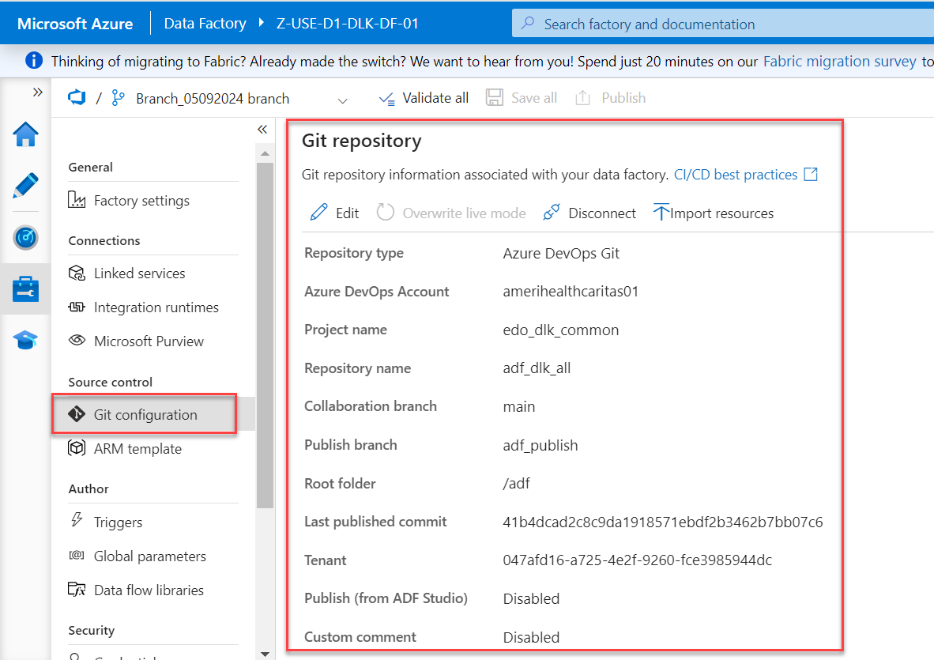

Never configure the Git repository configuration in QA ADF in any case even have edit access.
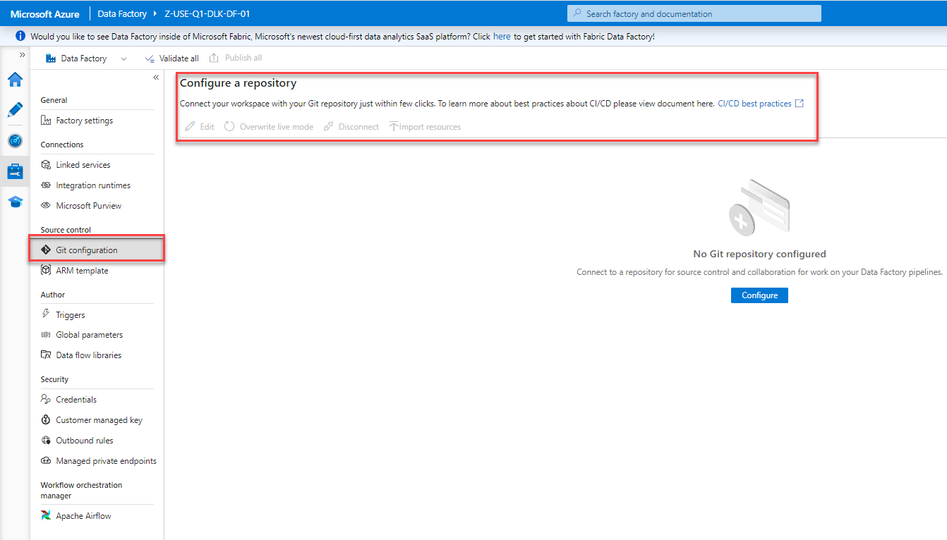
Use ITSM category ‘DevOps Tools Services’ to request repository access.
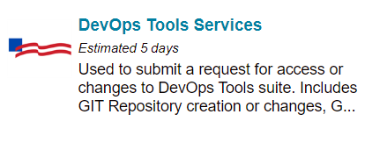

IIG Framework
All the developments in Data Lake2.0 must leverage the IIG Framework.
Please refer the IIG Framework details as follow,
IIG Framework
Review WHERE clause while creating update / delete statements for IIG metadata updates.

Security Considerations

Inputs and Outputs:
For most activities within a pipeline having full telemetry data for logging is a good thing. However, for some special cases the activity's output might become sensitive information that should be visible as plain text.
Maybe a Lookup activity is hitting a SQL Database and returning PII information. Or even a bear token is being passed downstream in a pipeline for an API call. In these cases, set the ‘Secure Input’ and ‘Secure Output’ attributes for the activity. Shown on the right. These settings are available in Data Factory for most external activities and when looking back in the monitoring have the following effect.
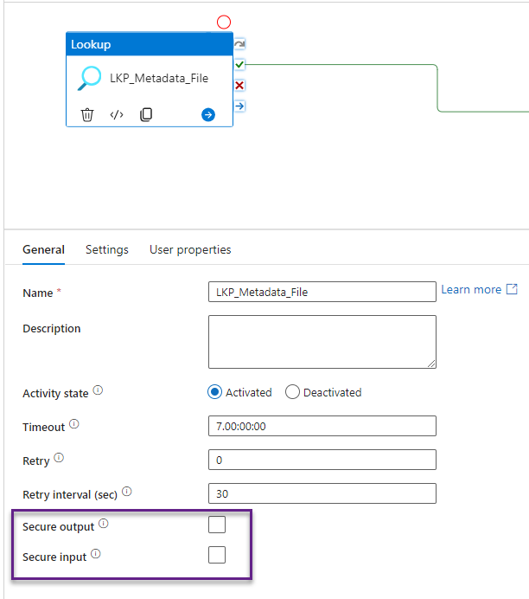

Credentials:
Do not hard code credentials in pipeline.
Azure Key Vault is now a core component of any solution, it should be in place holding the credentials for all our service interactions. In the case of Data Factory most Linked Service connections support the querying of values from Key Vault. Wherever possible we should be including this extra layer of security and allowing only Data Factory to retrieve secrets from Key Vault

Parallelism:

Parallel Execution:
Given the scalability of the Azure platform we should utilize that capability wherever possible. When working with Data Factory the ‘ForEach’ activity is a really simple way to achieve the parallel execution of its inner operations. By default, the ForEach activity does not run sequentially, it will spawn 20 parallel threads and start them all at once. Great! It also has a maximum batch count of 50 threads if you want to scale things out even further.
Please refer to the IIG Framework section for more details.
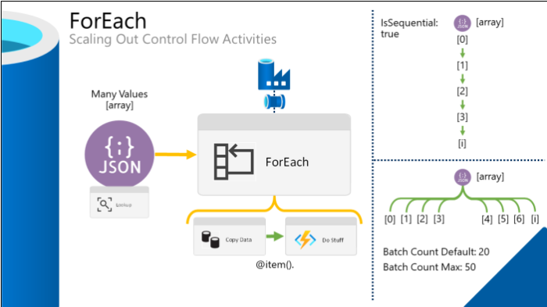

Service Limitations:
Please be aware that Azure Data Factory does have limitations. Both internally to the resource and across a given Azure Subscription. When implementing any solution and set of environments using Data Factory, please be aware of these limits.
The limit often encounter is where you can only have 40 activities per pipeline.

Reusable Code:

Dynamic Linked Services:
Reusing code is always a great time saver and means you often have a smaller footprint to update when changes are needed. Make all linked services dynamic (as required) using the feature and tick box called ‘Specify dynamic contents in JSON format ‘.
Please check if linked service already exists before creating new one.
Create your complete linked service definitions using this option and expose more parameters in your pipelines to complete the story for dynamic pipelines.

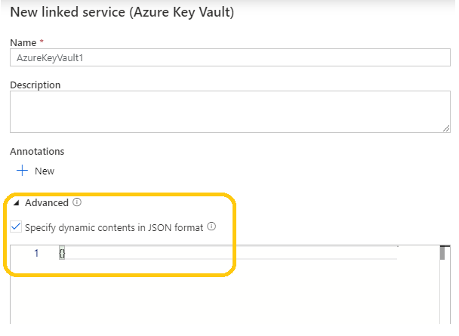

Generic Datasets
We can use a completely metadata driven dataset (IIG) for dealing with a particular type of object against a linked service. For example, one dataset for all CSV files from Blob Storage and one dataset for all SQLDB tables.
At runtime, the dynamic content underneath the dataset is created in full so monitoring is not impacted by making datasets generic. If anything, debugging becomes easier because of the common/reusable code. Where generic datasets are used, expect the following values to be passed as parameters.
Typically, from the pipeline, or resolved at runtime within the pipeline.
- Location – the file path, table location or storage container.
- Name – the file or table name.
- Structure – the attributes available provided as an array at runtime.

Reusable Code Template
Both point # 1.4.2 and 1.4.1 depicted in following document. No hardcoded values in the pipelines.
Parameterize ADF Workflows.docx

Pipelines design:

Pipeline design should follow the standard framework. Refer the Generic Pipelines design from TDD_StanadardLayerFramework.docx.
The Ingestion process should go till the standard layer.
- On-Prem to Raw
- Raw to Stage
- Stage to Standard.

Ensure to apply the proper Data Quality rules when loading the data into the Stage and Standard tables. Standard table should be created with proper datatype as per the source column datatypes.
All tables in Databricks should be created with proper naming, table definitions and column level definition.
Refer the same configuration in the IIG metadata configurations.

Audit Controls and Alerts

Audit:
Following Data Quality checks are mandatory,
- NULL check on Primary Key column(s), If the delta ingestion is upsert.
- The deduplication rule on key columns for target load type is upsert.
- NULL check on the referential column(s), If the recycle flag is enabled.
- Use DATA_QUALITY_RULES table for all DQ configurations.

All the rejects need to be captured in the reject table and email alert generated for the Production Support team.
Please refer to the IIG Framework section for more details.

Logs:
Every ADF pipeline must capture the lnamingog including child and parent pipelines.
Use following setup to configure log capture,
- There must be entry in table DATA_FACTORY_PIPELINE_SCHEDULE for every ADF pipeline (Including Parent, Child and Master).
- Every pipeline must start with START_BATCH_EXECUTION task.
  - It will generate log entry.
  - It will also check if the previous batch is still running.

Please refer to the IIG Framework section for more details.

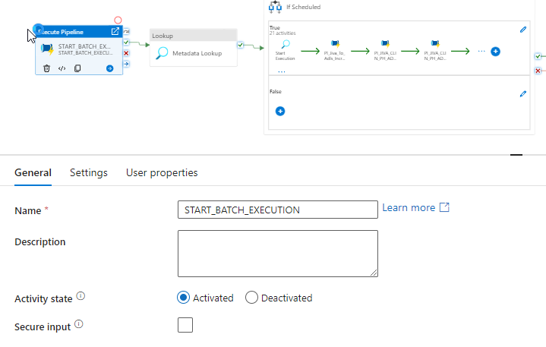

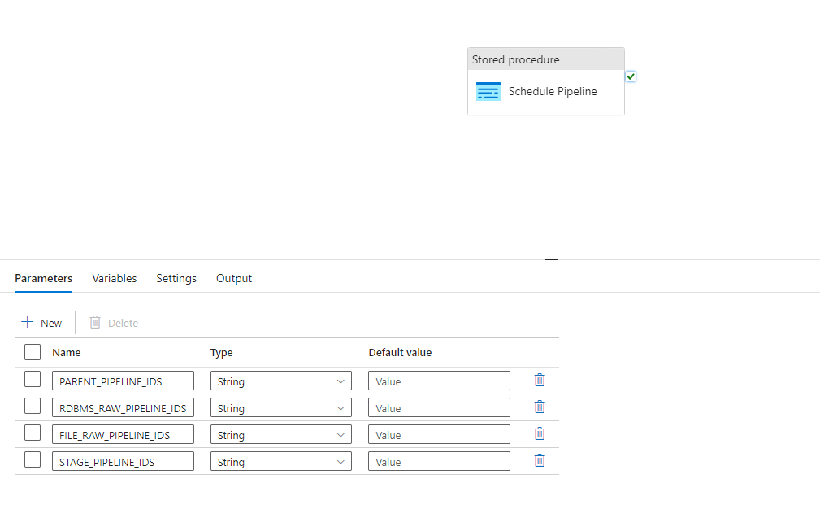

Alerts:
Every pipeline must have both success and failure email alerts to Production Support team DL ‘DL-ACFC: Azure Data Lake Production Support DLAzureDataLakeProdSupport@amerihealthcaritas.com’.
Leverage email temple to configure the email notifications as follow,
- Use config table EMAIL_TEMPLATE_CONFIG_TABLE for sending notification using logic app in different scenarios.
- No Need to hardcode any text, DL’s & other fields.
- Add new entries in existing table for new email notification.
- Depending on the Pipeline_ID & PROCESS_NAME, PROCESS_TYPE can do a lookup on Success, Failure, Partial Load message bodies and feed these inputs as parameters to Web activity to Trigger notification.

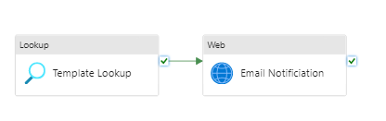

Steps to Create a Sample Email Look up
- Create an Entry in EMAIL_TEMPLATE_CONFIG with the Status on Success and Failure Messages.
Ex: select * FROM [dbo].[EMAIL_TEMPLATE_CONFIG] where process_name=’WC_EXTRACTION’
- Create a Pipeline Activity which invokes Pipeline “PL_EMAIL_NOTIFICATION_GENERIC” and pass the parameters as below.

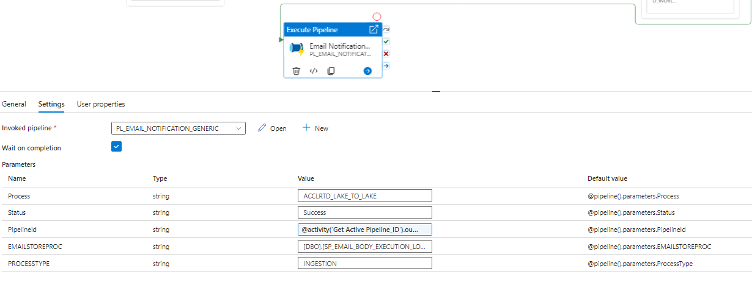
- Based on Ingestion or extraction the pipeline uses StoreProc “[DBO].[SP_EMAIL_BODY_EXECUTION_LOG_GENERIC]” to query the log tables and send email as output.
- Please refer to the IIG Framework section for more details.
- Follow following email templates,

Ingestion Email:

Subject: <Process/Source> <DL2.0 Layer> Data Load : <COMPLETED/FAILED> [If any file load fails the overall status should be FAILED]
Hi Team,
Please find the below details.
OBJECT_NAME | SRC_REC_COUNT | TGT_REC_COUNT | REJECTED_REC_COUNT | EXEC_STATUS | ERROR_MESSAGE | BATCH_DATE
<FIleName > | 0 | 0 | 0 | <COMPLETED / FAILED / NO NEW FILES TO PROCESS> | NA | <CURRENT_DATE>

Extraction Email:

Subject: <Process/Source> Extraction : <COMPLETED/FAILED>

Hi Team,

Files with COMPLETED status are copied to the following path on O Drive :<O drive location>.Please see the stats for individual files below:

EXTRCT_NM | EXTRCT_LOD_TYP | SRC_REC_COUNT | TGT_REC_COUNT | EXEC_STAT | BATCH_DATE | COMMENTS
<File Pattern> | <DELTA / FULL> | 338 | 338 | < COMPLETED / FAILED> | 2024-05-09 | MEMBERS_DISENROLLED_D_2100_20240509.txt  <Extracted File Name>

Gold/Consumption Email:

Subject: <Process/Source> <DL2.0 Layer> Data Load : <COMPLETED/FAILED> [If any data load fails the overall status should be FAILED]
Hi Team,
Please find the below details.
TABLE NAME | EXTRCT_LOD_TYP | BATCH DATE | MAX(UPDATE_DATE) | EXEC_STAT
<File Pattern> | <DELTA / FULL> | 338 | 338 | < COMPLETED / FAILED>

Timeout And Retry:
Almost every Activity within Data Factory has the following three settings (timeout, retry, retry interval) which fall under the policy section if viewing the underlying JSON:
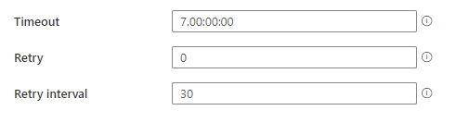
The screen shot above also shows the default values. Look carefully.
These default values cannot and should not be left in place when deploying Data Factory to production. A default timeout value of 7 days is huge and needs to be changed to (execution hours + 1 hour).

Databricks
Below are recommended coding standards for Databricks.

Security Considerations:

Credentials:
Do not hard code credentials in notebooks.
Azure Key Vault is now a core component of any solution, it should be in place holding the credentials for all our service interactions. All the secrets must be accessed through Key Vault in Databricks notebook.

Reusable Code:
Make the code more reusable and avoid redundant development, use common notebook concept wherever possible.
Leverage the IIG Framework as follow,

Notebook Layout

Heading
The first cell of the notebook should be a markdown cell. This cell should include:
– Purpose (high level)
– Business owner(s) / consumer(s) for requirement questions
– Dependencies (processes, table access, code sets) and location where to find more info on these (if
needed)
A notebook should be as concise as possible, and a function should not be over 70 lines of code.

Indentation
Use 4 spaces for each indentation level. Continuation lines should align the wrapped elements vertically as hanging indent. While using hanging indent, there should be no arguments in the first line and further indentation should be used to clearly distinguish it as a continuation line.

  - Adding two blank lines before functions and classes
  - Top level function and classes are separated with two blank lines.
  - Method definitions inside class should be separated with one blank line.

  - Extra blank lines may be used sparingly to separate a group of related functions.
  - Use blank lines in functions sparingly, to indicate logical sections.

# Top level function and class are separated with two blank lines
# Function definitions within a class are separated with single blank line

  - Limiting Line
  - Lengths Limit all lines to a maximum of 79 characters.
  - For flowing long blocks of text with fewer structural restrictions (docstrings or comments), the line length should be restricted to 72 characters.

  - Imports
  - Imports should usually be in separate lines.
  - Wildcard imports should be avoided, as it will not give a clear picture of what names are present in namespace.

  - Vacuum
  - Vacuum command must be used in Delta Lake tables

General Recommendations
  - Comparing singletons
  - Use ‘is’ while comparing singletons.
  - Use ‘is not’ instead of ‘not … is’

  - Avoid lambda expression.

  - Always use ‘def’ statement instead of an assignment statement for anonymous (lambda) expressions.

  - Deriving Exceptions
  - Derive exceptions from ‘Exception’ instead of ‘BaseException’
  - Use explicit exception catching as much as possible. Avoid implicit exception catching.
  - Keep ‘try’ section logic as simple as possible

  - Boolean Comparison
  - Booleans are already Booleans. They don’t need comparisons.
  - For sequences (e.g., Lists), use the fact that the empty sequences represent false.

  - Avoid print statements. Use logging module.
  - Use Merge instead of Update in tables.
  - Ensure reusability of code modules throughout the file. Use existing reusable components instead of creating new functions redundantly.
  - While using recursive function with Spark, make sure it has an appropriate break statement. Otherwise, it will lead to over-utilization of resources.
  - Usernames, Passwords, Hostnames should not be maintained in direct python file or notebook. Sensitive information should be managed in secure vault, and it should be referenced in python file or notebook using keys.
  - While using SQL statements, it is recommended to assign the SQL statement to a variable. And use the variable in Spark SQL API.

  - Refactor complex chaining of expressions. It’s recommended to apply multi-line expressions with different types, especially if they have different behaviors and context. Example is, mixing column creation or joining with selecting and filtering.

  - Use select statement to specify a schema contract. Making a selection at the beginning of the transform, or before returning, is considered a good practice. Any selection should be seen as a cleaning operation that is preparing the dataframe for consumption by the next step in the transform.
  - Keep select statements as simple as possible. Due to common SQL idioms, allow only one function from spark.sql.function to be used per selected column, plus an optional .alias() to give it a meaningful name.
  - Expressions involving more than one dataframe, or conditional operations like .when() are discouraged to be used in a select, unless required for performance reasons.

  - Instead of using withColumnRenamed(), use aliases. Also, instead of using withColumn() to redefine type, cast it in the select.

  - In places where an empty column is required to be added to satisfy the schema, always use F.lit(None) function for populating empty column. Never use an empty string or other value that represents empty like “NA”, “N/A”, “Nil”.
  - Though it is semantically right to use so, the primary reason for recommending using F.lit(None) is to preserve the ability to use utilities like isNull, instead of verifying empty string, “NA”, “N/A”, “Nil”.

  - User-Defined Functions (UDF)
It is highly recommended to avoid UDFs in all situations, as it is less performant than native PySpark. In most cases, logic that necessitates a UDF can be refactored to get of UDF and use only native PySpark API.

  - Joins
It is recommended to be more cautious when using joins. For instance, when we perform a left join and the right-side table has multiple matches for a key, then the row will be duplicated as many times as there are matches. This will heavily impact the output of transformation job.
Always specify the keyword explicitly, even if you are doing default inner join.

  - Avoid using right-join. If you are about to use right-join, change the order of the dataframes in such a way to use a left-join instead. It is more intuitive since the dataframe you are doing operation on, is the one that you are performing your join around.
  - cache() is an Apache Spark transformation that can be used on RDD, Dataframe or Dataset when you perform more than one operation with this entity (RDD/Dataframe/Dataset). As cache() is a transformation operation, the caching operation takes place only when a Spark action (count, show, take or write) is also performed on the same dataframe, dataset or RDD in a single action,

  - In the above snippet, Dataframe df1 will be cached into memory only when df1.count() action is executed. df1.cache() does not initiate the caching operation on Dataframe df1.
  - In the above snippet, Dataframe df will be cached into memory when take(10) action is executed. However, there is a catch in this action that only one partition will be cached. That is, take(10) process only 10 records and the partition associated to those 10 records, will only be cached and other partitions will not be cached. As a result, the next statement df.count() will create the dataframe df again. Rather df.cache.count() will cache the records from all partitions. Hence, it is recommended to use df.cache.count() wherever the use cases require all data to cache.

  - String Comparison
Databricks string comparison is case sensitive and cannot compare strings with different casing.
Result:
+———————+—————-+—————-+
|WithoutLowerUpper|WithLowerCase|WithUpperCase|
+———————+—————-+—————-+
| false| true| true|
+———————+—————-+—————-+

  - Table Partitioning
Delta tables in Databricks support partitioning which enhances performance. You can partition by a column if you expect data in that partition to be at least 1GB. If column cardinality is high, do not use that column for partitioning. For example, you partition by user ID and there are 1M distinct user IDs, partitioning would increase table load time. Example:

  - Delta Lake performance using OPTIMIZE with ZORDER
  - Z-Ordering is an approach to collocate related information in the same set of files. The technique of co-locality is automatically applied by data-skipping algorithms in Delta Lake on Databricks, to greatly reduce the amount of data to be read. To Z-Order data, specify the columns to be ordered on in the ZORDER BY clause.
  - Use of Repartition hints for balancing partitions.
Below are the different partitioning hint types,
COALESCE | Reduce the number of partitions to the specified number of partitions. It takes a partition number as a parameter
REPARTITION | Repartition to the specified number of partitions using the specified partitioning expressions. It takes partition number, column names, or both as parameters
REPARTITION_BY_RANGE | Repartition to the specified number of partitions using the specified partitioning expressions. It takes column names and an optional partition number as parameters
REBALANCE | REBALANCE hints can be used to rebalance the query result output partitions, so that every partition is of a reasonable size. It can take column names as parameters. This hint will be useful when we need to write the result of the query to a table, to avoid too small/big files. This hint is ignored if AQE (Adaptive Query Execution) is not enabled.

  - Delete temporary table after notebook execution
  - Use temp database ‘tempdb’ in every environment (Dev, QA, UAT & Prod) for storing temp data/tables.
  - Delete temporary tables that were created as intermediate tables during notebook execution. Deleting tables saves storage, especially if the notebook is scheduled daily.

  - Use views when creating intermediate tables
If we need to create intermediate tables, use views to minimize storage usage and save costs. Views are session-oriented and will automatically remove tables from storage after the query execution. For optimal query performance, do not use joins or subqueries in views

  - Table definitions with Liquid Clustering
It’s recommended to use Liquid Clustering for new tables that are getting created in Databricks.
Syntax: CREATE OR REPLACE TABLE TABLENAME CLUSTER BY AUTO

  - Cluster for Job
Must use Databricks Job Pools clusters with DBR >= 15.4 LTS with Photon enabled only.
For every project it’s recommended to have project specific cluster, access token and Data access groups based on the requirement. Before the design or development start connect with Platform team to determine the size of the cluster.
For more refer  TDD Details - DL2.0 Platform Standards.docx

Tidal Schedular

All ADF pipeline should be scheduled through Tidal schedular. Refer the Guidelines for Integrating ADF Pipeline with Tidal.docx for the standards on Integrating the ADP pipelines with Tidal

